**Week 1**

**Getting Started**

**MSDS 674 GIS**

**Regis University**

**Ahmad Alqurashi**

In first week assignment, we are going to use ArcGIS Pro, which is a GIS platform where you can explore, visualize, analyze data, create 2D and 3D maps, to create a project add data and modify a map and create a layout. Below are the steps to create a layout.

* Create project

First step is to create project, which will create a project with a map of the world.

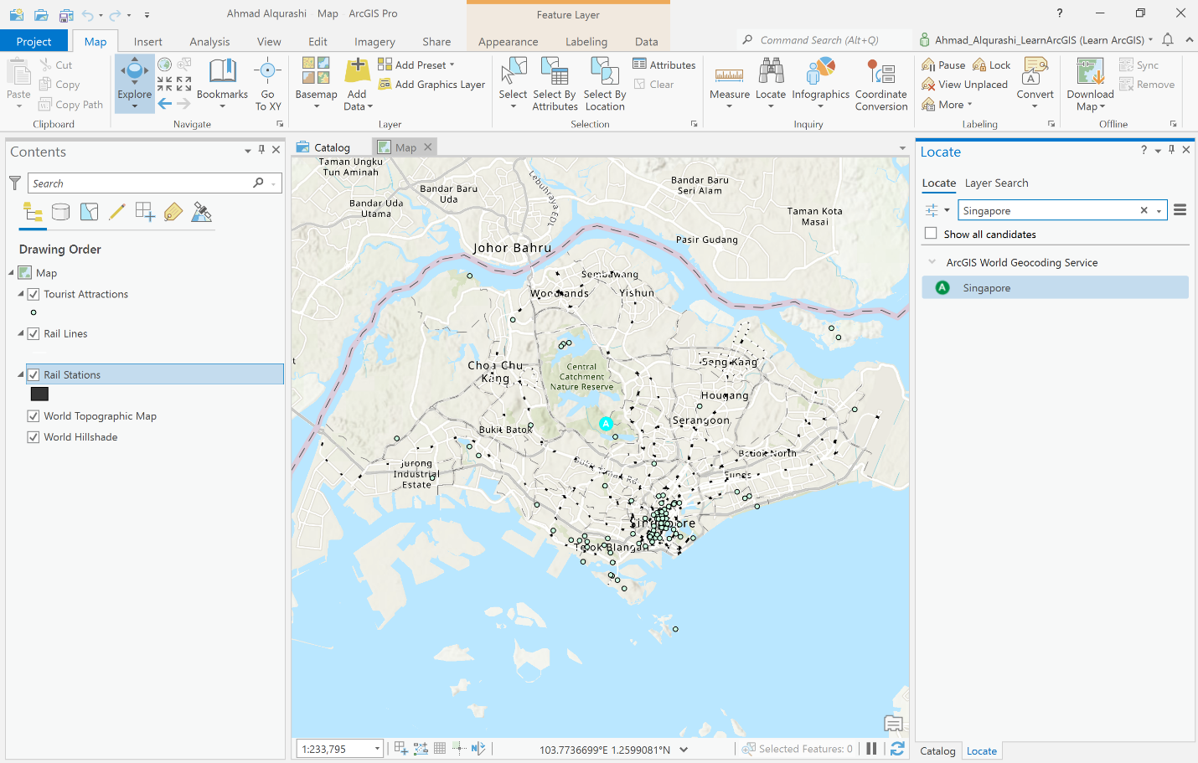

Figure empty project

* Navigate to Singapore

Figure 1 shows that we used explore function in ArcGIS to navigate to Singapore.

* Add data

ArcGIS has the ability to add data to maps, data can be added from several sources such as local device, or ArcGIS online open data. In Figure 2, we added Tourist Attractions in Singapore and Rails data to the map.

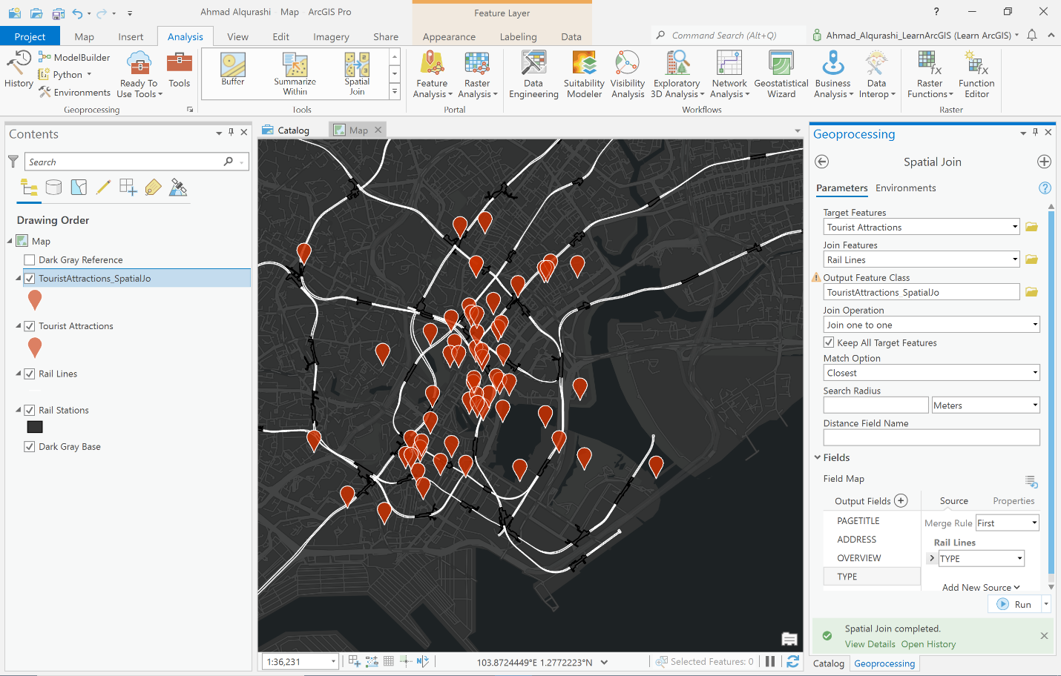

Figure Downtown Singapore

* Style the Map

We can change the style of the map in ArcGIS. Figure 2 shows that we used Dark Gray Canvas style. We can Also change the appearance of the pins.

* Determine proximity

ArcGIS Also has the ability to measure distance between multiple data. Here we can use Spatial join function to measure between each tourist attraction and rail station

* Export a table

As we used spatial join function to measure distance, ArcGIS created a joined table for these data. We can export this data to have on our compute. Figure 3 shows the table we exported.

Figure table

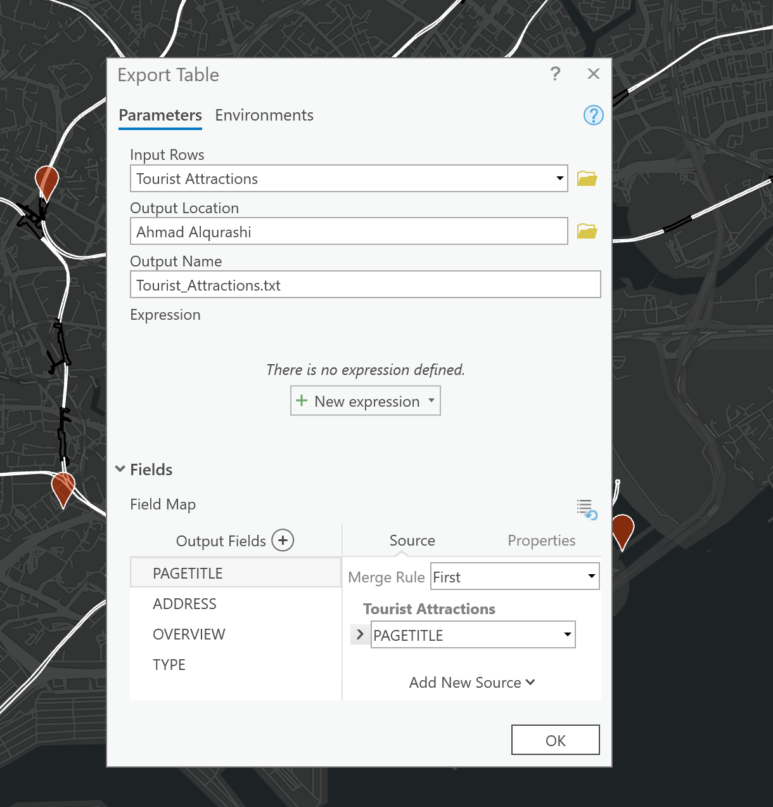

Figure export table function

* Label features

With the pins we added to the map, we can add labels to them to make them more informative to the tourists. Figure 5 shows that we added label to the features in the map. However, they are textual and overlapping each other so they are hard to read. Instead, we are going to change textual information with numbers.

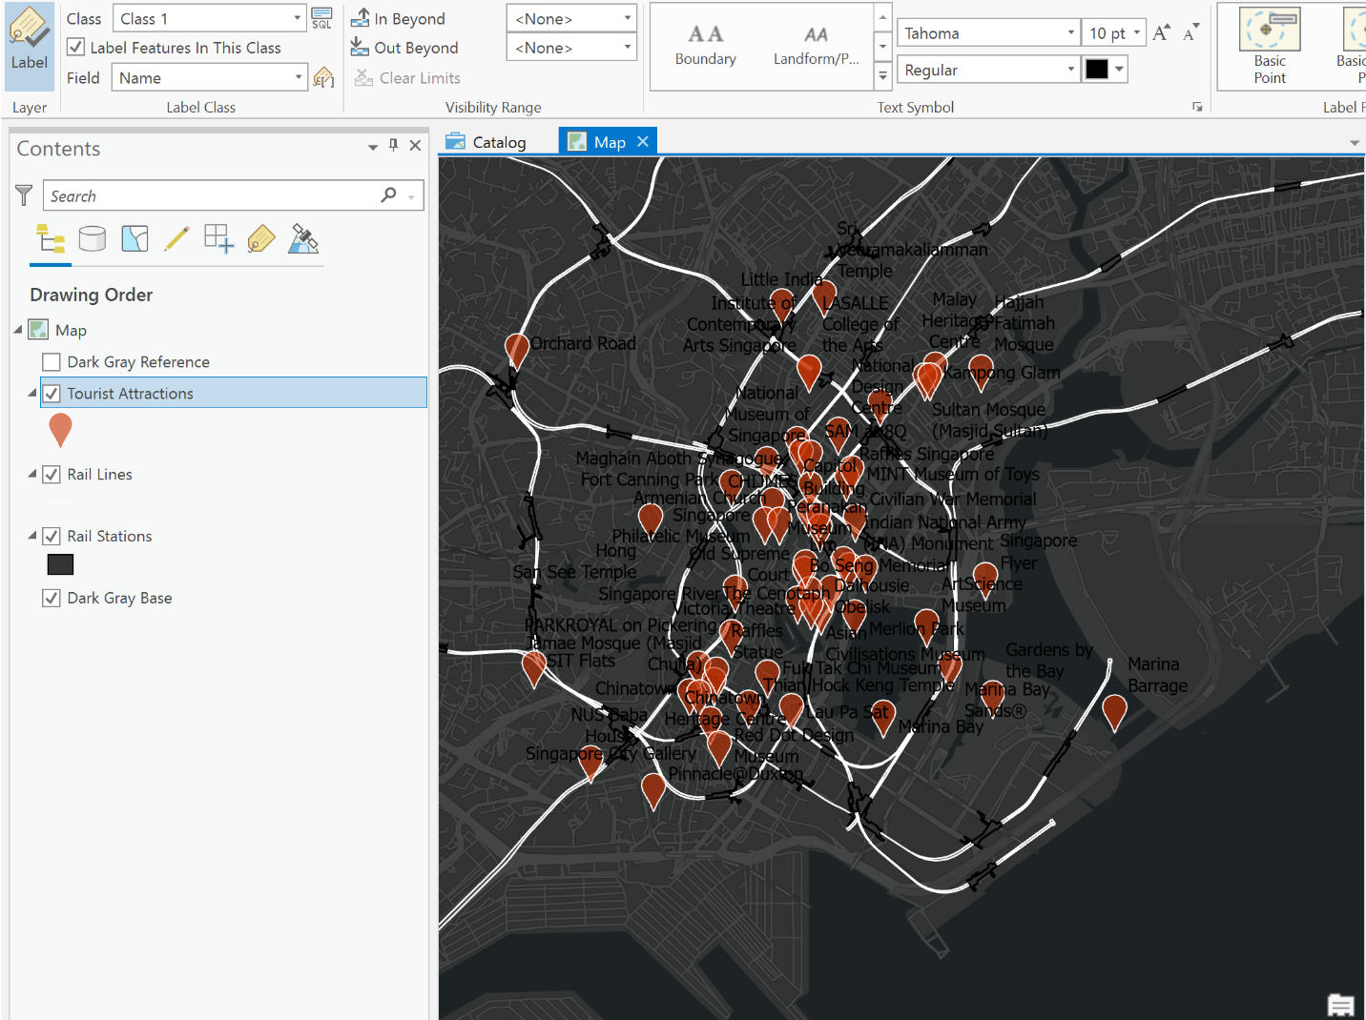

Figure labeled features

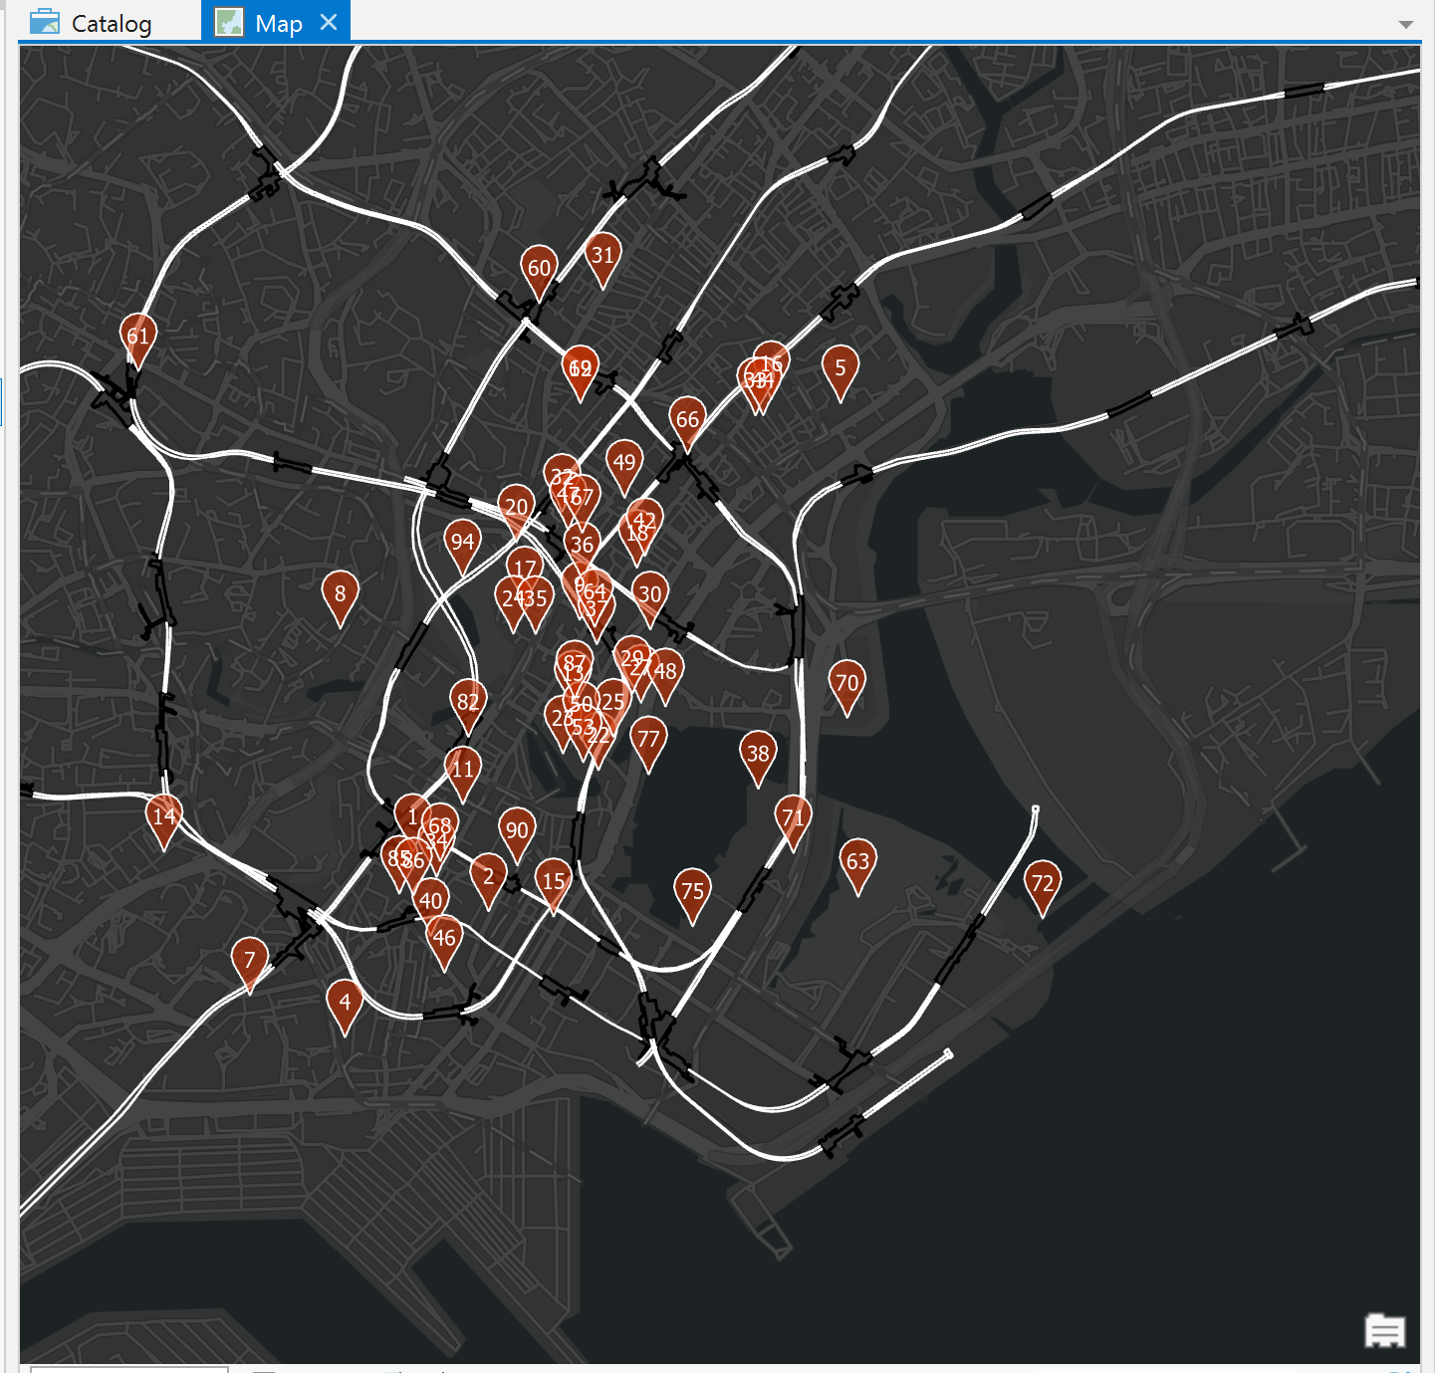

Figure labeled with number

Figure 6 shows the map with tourists’ attractions in numbers, and the numbers are centered witch makes it easy to read.

* Create Layout

Now, the map is ready to be exported and printed out or distributed across Internet. In order to export it, we create a layout. The layout contains the rail stations and tourists’ attractions with legend, map title, scale, and description. Figure 7 shows the final layout.

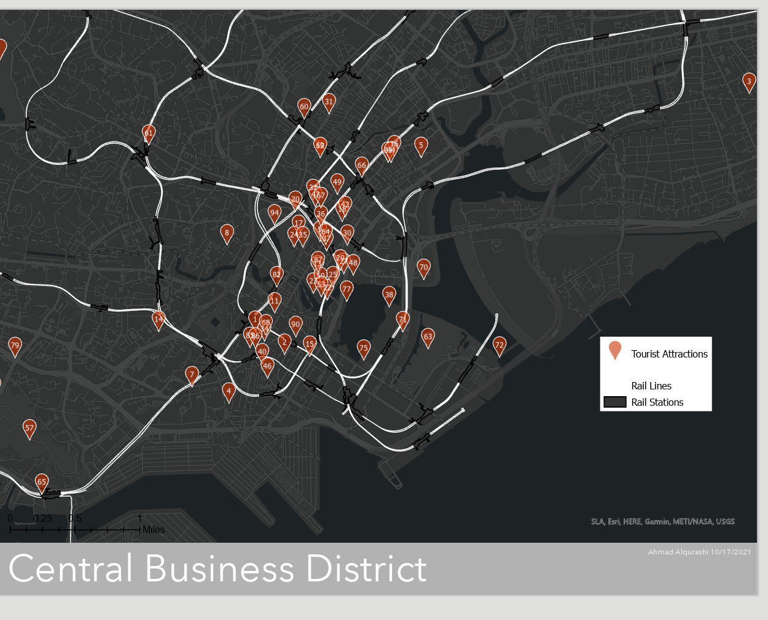

Figure Map Layout